DATA STRUCTURES AND ALGORITHMS LAB – 6
Student Details
- Name: Pratyush Deo Singh
- Registration Number: 25BCE5101
- Course / Branch: B. Tech. CSE (Core)
- Semester: 2nd
- Subject: Data Structures and Algorithms
- Faculty Name: Dr Malini A

Program 1: Menu Driven Singly Linked List
Program Code
1_singly_linked_list_menu.c
1 | #include <stdio.h>
2 | #include <stdlib.h>
3
4 | struct node {
5 | int data;
6 | struct node *next;
7 | };
8
9 | struct node *head = NULL;
10
11 | void insert_begin() {
12 | int x;
13 | struct node *n = malloc(sizeof(struct node));
14 | scanf("%d", &x);
15 | n->data = x;
16 | n->next = head;
17 | head = n;
18 | }
19
20 | void insert_end() {
21 | int x;
22 | struct node *n = malloc(sizeof(struct node));
23 | scanf("%d", &x);
24 | n->data = x;
25 | n->next = NULL;
26
27 | if (head == NULL) {
28 | head = n;
29 | return;
30 | }
31
32 | struct node *t = head;
33 | while (t->next != NULL)
34 | t = t->next;
35 | t->next = n;
36 | }
37
38 | void insert_pos() {
39 | int x, pos, i = 1;
40 | scanf("%d %d", &x, &pos);
41
42 | if (pos == 1) {
43 | insert_begin();
44 | return;
45 | }
46
47 | struct node *n = malloc(sizeof(struct node));
48 | n->data = x;
49
50 | struct node *t = head;
51 | while (i < pos - 1 && t != NULL) {
52 | t = t->next;
53 | i++;
54 | }
55
56 | if (t == NULL)
57 | return;
58
59 | n->next = t->next;
60 | t->next = n;
61 | }
62
63 | void delete_begin() {
64 | if (head == NULL)
65 | return;
66 | struct node *t = head;
67 | head = head->next;
68 | free(t);
69 | }
70
71 | void delete_end() {
72 | if (head == NULL)
73 | return;
74
75 | if (head->next == NULL) {
76 | free(head);
77 | head = NULL;
78 | return;
79 | }
80
81 | struct node *t = head;
82 | while (t->next->next != NULL)
83 | t = t->next;
84
85 | free(t->next);
86 | t->next = NULL;
87 | }
88
89 | void delete_pos() {
90 | int pos, i = 1;
91 | scanf("%d", &pos);
92
93 | if (pos == 1) {
94 | delete_begin();
95 | return;
96 | }
97
98 | struct node *t = head;
99 | while (i < pos - 1 && t != NULL) {
100 | t = t->next;
101 | i++;
102 | }
103
104 | if (t == NULL || t->next == NULL)
105 | return;
106
107 | struct node *d = t->next;
108 | t->next = d->next;
109 | free(d);
110 | }
111
112 | void display() {
113 | struct node *t = head;
114 | while (t != NULL) {
115 | printf("%d ", t->data);
116 | t = t->next;
117 | }
118 | printf("\n");
119 | }
120
121 | void modify_by_value() {
122 | int oldv, newv;
123 | scanf("%d %d", &oldv, &newv);
124
125 | struct node *t = head;
126 | while (t != NULL) {
127 | if (t->data == oldv) {
128 | t->data = newv;
129 | return;
130 | }
131 | t = t->next;
132 | }
133 | }
134
135 | void modify_by_pos() {
136 | int pos, newv, i = 1;
137 | scanf("%d %d", &pos, &newv);
138
139 | struct node *t = head;
140 | while (i < pos && t != NULL) {
141 | t = t->next;
142 | i++;
143 | }
144
145 | if (t != NULL)
146 | t->data = newv;
147 | }
148
149 | int main() {
150 | int ch;
151 | while (1) {
152 | scanf("%d", &ch);
153
154 | if (ch == 1) insert_begin();
155 | else if (ch == 2) insert_end();
156 | else if (ch == 3) insert_pos();
157 | else if (ch == 4) delete_begin();
158 | else if (ch == 5) delete_end();
159 | else if (ch == 6) delete_pos();
160 | else if (ch == 7) display();
161 | else if (ch == 8) modify_by_value();
162 | else if (ch == 9) modify_by_pos();
163 | else break;
164 | }
165 | return 0;
166 | }
167

Output
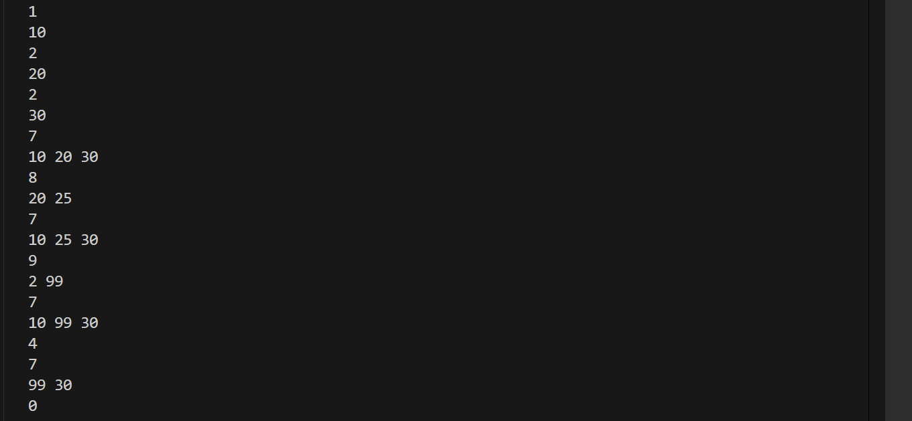
Program 2: Search an Element in Singly Linked List
Program Code
2_search_sll.c
1 | #include <stdio.h>
2 | #include <stdlib.h>
3
4 | struct node {
5 | int data;
6 | struct node *next;
7 | };
8
9 | int main() {
10 | struct node *head = NULL, *temp, *newnode;
11 | int n, x, key, pos = 1, found = 0;
12
13 | scanf("%d", &n);
14
15 | for (int i = 0; i < n; i++) {
16 | scanf("%d", &x);
17 | newnode = malloc(sizeof(struct node));
18 | newnode->data = x;
19 | newnode->next = NULL;
20
21 | if (head == NULL)
22 | head = newnode;
23 | else {
24 | temp = head;
25 | while (temp->next != NULL)
26 | temp = temp->next;
27 | temp->next = newnode;
28 | }
29 | }
30
31 | scanf("%d", &key);
32
33 | temp = head;
34 | while (temp != NULL) {
35 | if (temp->data == key) {
36 | printf("Found at position %d", pos);
37 | found = 1;
38 | break;
39 | }
40 | temp = temp->next;
41 | pos++;
42 | }
43
44 | if (!found)
45 | printf("Not Found");
46
47 | return 0;
48 | }
49
Output
Program 3: Count Number of Nodes in Singly Linked List
Program Code
3_count_nodes_sll.c
1 | #include <stdio.h>
2 | #include <stdlib.h>
3
4 | struct node {
5 | int data;
6 | struct node *next;
7 | };
8
9 | int main() {
10 | struct node *head = NULL, *temp, *newnode;
11 | int n, x, count = 0;
12
13 | scanf("%d", &n);
14
15 | for (int i = 0; i < n; i++) {
16 | scanf("%d", &x);
17 | newnode = malloc(sizeof(struct node));
18 | newnode->data = x;
19 | newnode->next = NULL;
20
21 | if (head == NULL)
22 | head = newnode;
23 | else {
24 | temp = head;
25 | while (temp->next != NULL)
26 | temp = temp->next;
27 | temp->next = newnode;
28 | }
29 | }
30
31 | temp = head;
32 | while (temp != NULL) {
33 | count++;
34 | temp = temp->next;
35 | }
36
37 | printf("Count = %d", count);
38
39 | return 0;
40 | }
41
Output

Program 4: Reverse a Singly Linked List
Program Code
4_reverse_sll.c
1 | #include <stdio.h>
2 | #include <stdlib.h>
3
4 | struct node {
5 | int data;
6 | struct node *next;
7 | };
8
9 | int main() {
10 | struct node *head = NULL, *temp, *newnode;
11 | struct node *prev = NULL, *curr, *next;
12 | int n, x;
13
14 | scanf("%d", &n);
15
16 | for (int i = 0; i < n; i++) {
17 | scanf("%d", &x);
18 | newnode = malloc(sizeof(struct node));
19 | newnode->data = x;
20 | newnode->next = NULL;
21
22 | if (head == NULL)
23 | head = newnode;
24 | else {
25 | temp = head;
26 | while (temp->next != NULL)
27 | temp = temp->next;
28 | temp->next = newnode;
29 | }
30 | }
31
32 | curr = head;
33 | while (curr != NULL) {
34 | next = curr->next;
35 | curr->next = prev;
36 | prev = curr;
37 | curr = next;
38 | }
39
40 | head = prev;
41
42 | temp = head;
43 | while (temp != NULL) {
44 | printf("%d ", temp->data);
45 | temp = temp->next;
46 | }
47
48 | return 0;
49 | }
50
Output

Program 5: Sort a Singly Linked List
Program Code
5_sort_sll.c
1 | #include <stdio.h>
2 | #include <stdlib.h>
3
4 | struct node {
5 | int data;
6 | struct node *next;
7 | };
8
9 | int main() {
10 | struct node *head = NULL, *temp, *newnode, *i, *j;
11 | int n, x, t;
12
13 | scanf("%d", &n);
14
15 | for (int k = 0; k < n; k++) {
16 | scanf("%d", &x);
17 | newnode = malloc(sizeof(struct node));
18 | newnode->data = x;
19 | newnode->next = NULL;
20
21 | if (head == NULL)
22 | head = newnode;
23 | else {
24 | temp = head;
25 | while (temp->next != NULL)
26 | temp = temp->next;
27 | temp->next = newnode;
28 | }
29 | }
30
31 | for (i = head; i != NULL; i = i->next) {
32 | for (j = i->next; j != NULL; j = j->next) {
33 | if (i->data > j->data) {
34 | t = i->data;
35 | i->data = j->data;
36 | j->data = t;
37 | }
38 | }
39 | }
40
41 | temp = head;
42 | while (temp != NULL) {
43 | printf("%d ", temp->data);
44 | temp = temp->next;
45 | }
46
47 | return 0;
48 | }
49
Output
Result
All the programs related to Singly Linked List were successfully implemented and executed.

